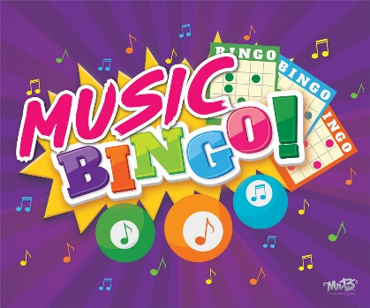

Kindergarten – 2nd Grade Music Bingo​
​
Color in each square you complete. Can you get five in a row? If you get BINGO, have your parents take a picture of you with your completed form and post your picture to the music SeeSaw!

​
Name: ________________________________________​

Teacher: _______________________________________

​  Draw a quarter note​ (ta) | ​  Sing a song to a friend or family member​ | ​  Sing one note for 10 seconds​ | ​  Draw a picture of  your favorite instrument | ​  Listen to a song  and decide if it  makes you feel  happy or sad
​  Skip around the room​ while singing your favorite song | ​  ​Sing a song fortissimo  (very loud) | ​  Sing a song that has animals in it.  Example…  Old MacDonald, BINGO, Baby Shark  ​ | ​  Have a Dance Party​  with your family | ​  Find something in  your house that has  a music note on it
​  Ask a family member what their favorite  instrument​ is | ​  Make a shaker with items from your kitchen (with  permission!) | FREE SPACE​  ​  ​ | ​  Make up a song about a person in your family and sing it to them | ​  Sing the lowest note you can
​  Sing a song in the shower or the bathtub | ​  Find something to use as a drum (with permission!)​ | ​Sing the ABC song as fast as you can | ​  Make a card for someone and decorate it with music notes | Watch your favorite TV show and count how many times you hear music during your show
​  Walk around your yard 3X and sing a different song each time | ​  Play the freeze dance​ | ​  Ask a family member to teach you a new song | ​  Sing a song pianissimo  (very softly) | ​  ​Sing the highest note you can

